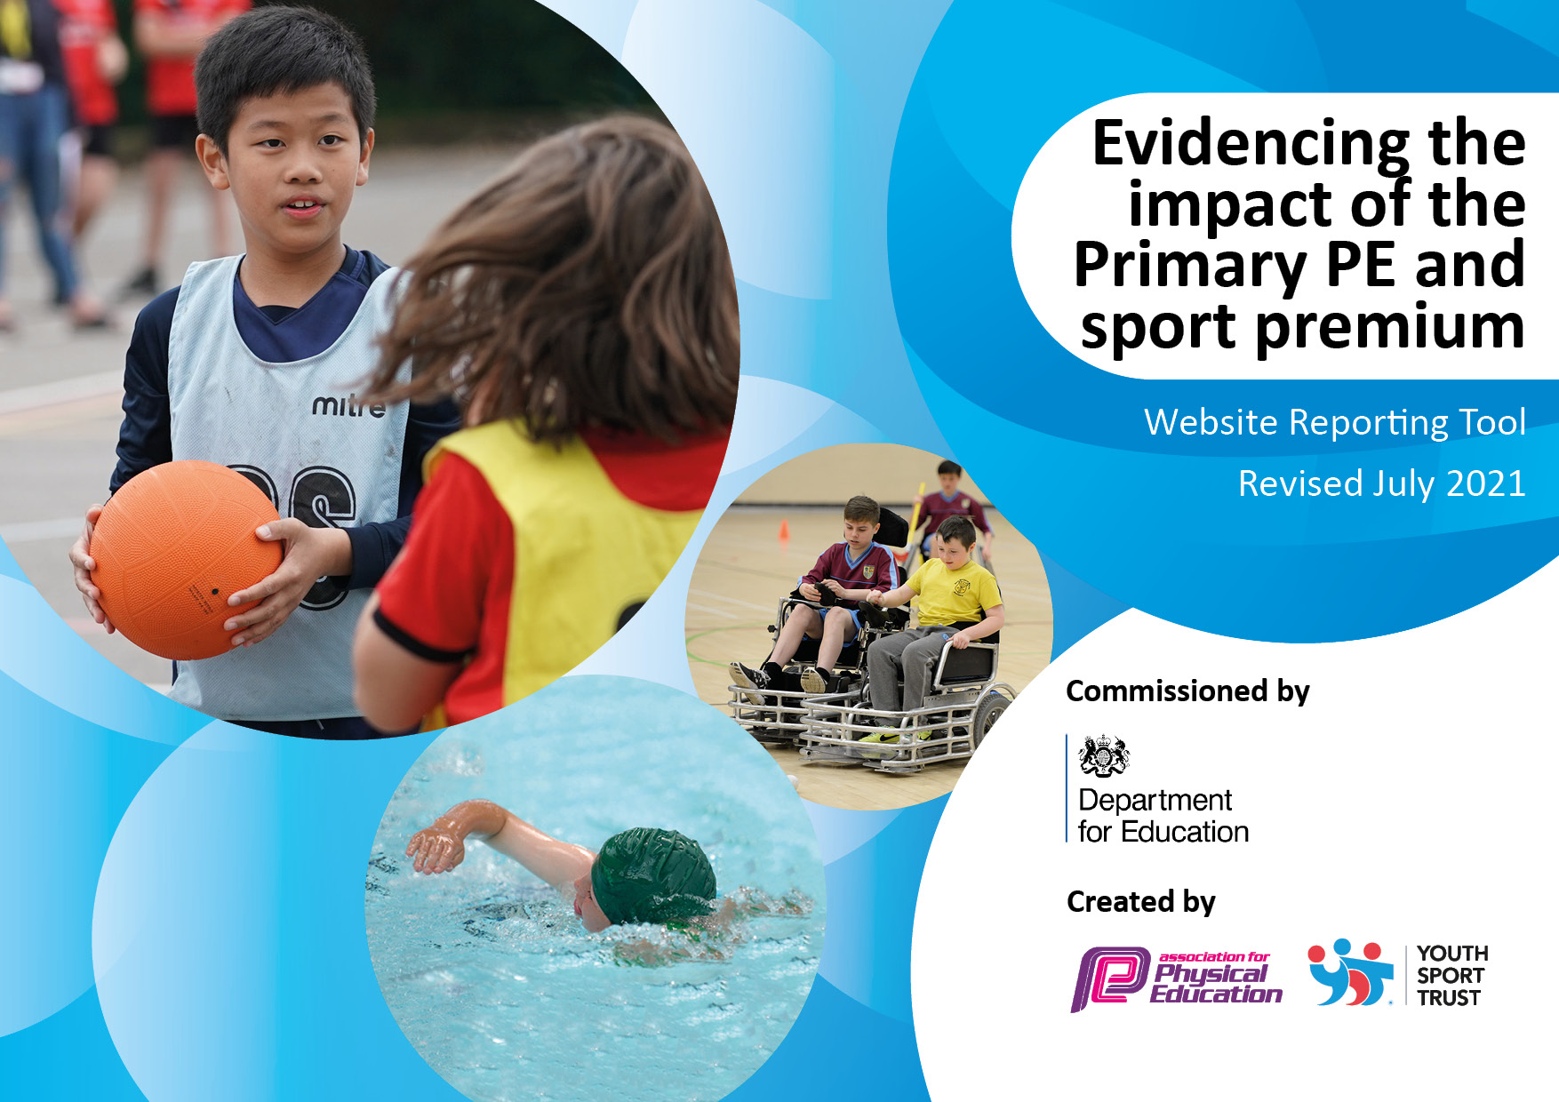

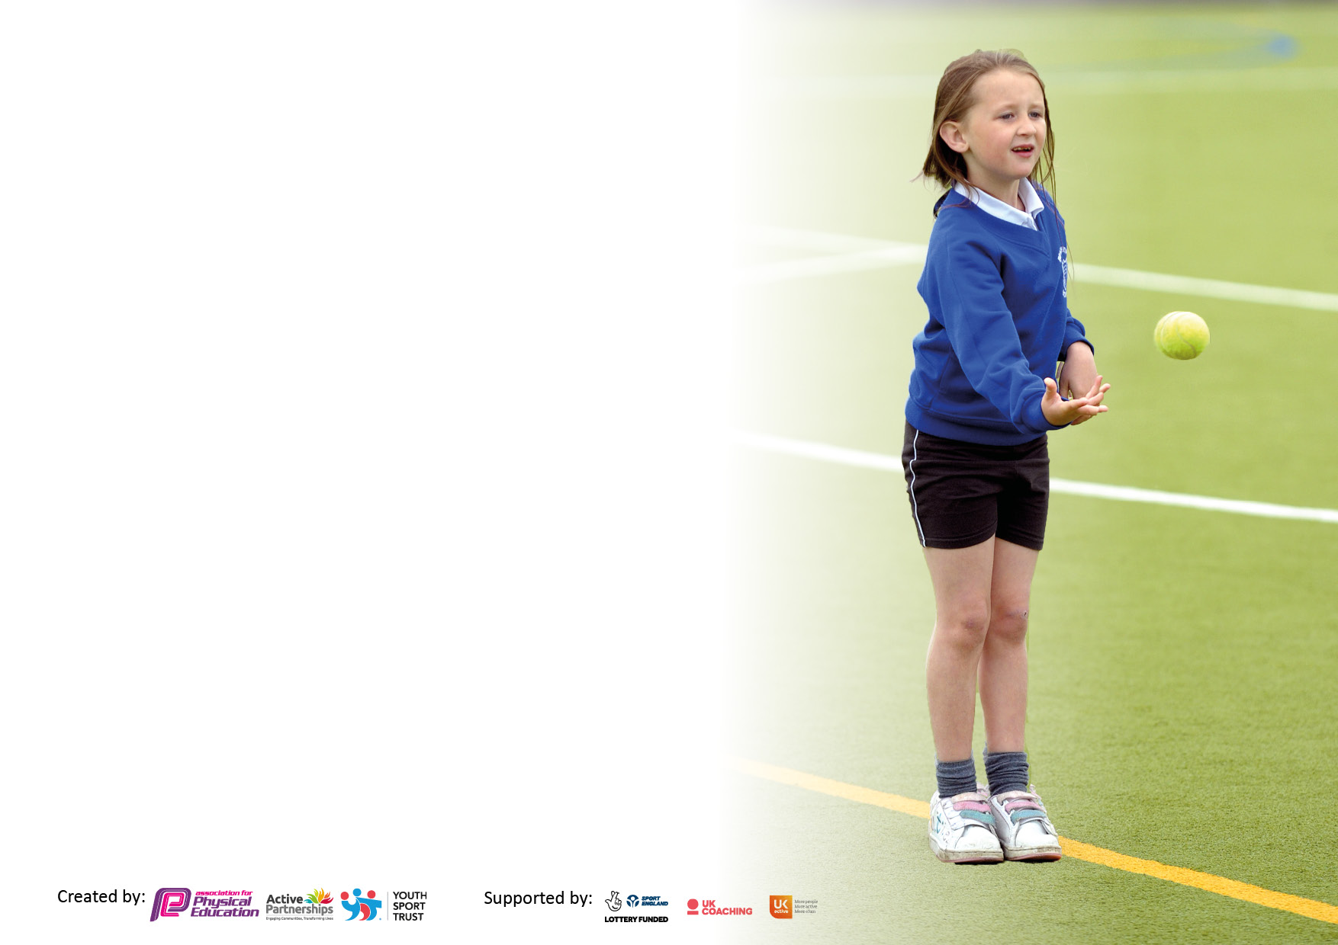

It is important that your grant is used effectively and based on school need. The Education Inspection Framework makes clear there will be a focus on **‘whether leaders and those responsible for governors all understand their respective roles and perform these in a way that enhances the effectiveness of the school’**.

Under the Quality of Education Ofsted inspectors consider:

**Intent** - Curriculum design, coverage and appropriateness

**Implementation** - Curriculum delivery, Teaching (pedagogy) and Assessment

**Impact** - Attainment and progress

To assist schools with common transferable language this template has been developed to utilise the same three headings which should make your plans easily transferable between working documents.

Schools must use the funding to make **additional and sustainable** improvements to the quality of Physical Education, School Sport and Physical Activity (PESSPA) they offer. This means that you should use the Primary PE and sport premium to:

* Develop or add to the PESSPA activities that your school already offer
* Build capacity and capability within the school to ensure that improvements made now will benefit pupils joining the school in future years
* The Primary PE and sport premium should not be used to fund capital spend projects; the school’s budget should fund these.

Pleasevisitgov.ukfortherevisedDfEguidanceincludingthe5keyindicatorsacrosswhichschoolsshoulddemonstrate animprovement.Thisdocumentwillhelpyoutoreviewyourprovisionandtoreportyourspend.DfEencouragesschools to use this template as an effective way of meeting the reporting requirements of the Primary PE and sport premium.

We recommend you start by reflecting on the impact of current provision and reviewing the previous spend.

Schools are required to publish details of how they spend this funding, including any under-spend from 2019/2020, as well as on the impact it has on pupils’ PE and sport participation and attainment. **All funding must be spent by 31st July 2022.**

We recommend regularly updating the table and publishing it on your website throughout the year. This evidences your ongoing self-evaluation of how you are using the funding to secure maximum, sustainable impact. Final copy must be posted on your website by the end of the academic year and no later than the 31st July 2021. To see an example of how to complete the table please click HERE.

Created by: Supported by:

**Details with regard to funding**

Please complete the table below.

|  |  |
| --- | --- |
| Total amount carried over from 2019/20 | £3000 |
| Total amount allocated for 2020/21 | £18,720 |
| How much (if any) do you intend to carry over from this total fund into 2021/22? | £0 |
| Total amount allocated for 2021/22 | £18,590 |
| Total amount of funding for 2021/22. To be spent and reported on by 31st July 2022. | £18,590 |

**Swimming Data**

Please report on your Swimming Data below.

|  |  |
| --- | --- |
| Meeting national curriculum requirements for swimming and water safety.  N.B. Complete this section to your best ability. For example, you might have practised safe self-rescue techniques on dry land which you can then transfer to the pool when school swimming restarts.  **Due to exceptional circumstances priority should be given to ensuring that pupils can perform safe self rescue even if they do not fully meet the first two requirements of the NC programme of study** |  |
| What percentage of your current Year 6 cohort swim competently, confidently and proficiently over a distance of at least 25 metres?  **N.B.** Even though your pupils may swim in another year please report on their attainment on leaving primary school at the end of the summer term 2020.  Please see note above | 66% |
| What percentage of your current Year 6 cohort use a range of strokes effectively [for example, front crawl, backstroke and breaststroke]?  Please see note above | 73% |
| **What percentage of your current Year 6 cohort perform safe self-rescue in different water-based situations?** | 73% |
| Schools can choose to use the Primary PE and sport premium to provide additional provision for swimming but this must be for activity **over and above** the national curriculum requirements. Have you used it in this way? | Yes/No |

**Action Plan and Budget Tracking**

Capture your intended annual spend against the 5 key indicators. Clarify the success criteria and evidence of impact that you intend to measure to evaluate for pupils today and for the future.

|  |  |  |  |  |
| --- | --- | --- | --- | --- |
| **Academic Year:** 2020/21 | **Total fund allocated:** | **Date Updated: 07/11/21** | |  |
| **Key indicator 1:** The engagement of all pupils in regular physical activity – Chief Medical Officers guidelines recommend that primary school pupils undertake at least 30 minutes of physical activity a day in school | | | | Percentage of total allocation: |
| 83% |
| **Intent** | **Implementation** | | **Impact** |  |
| Development of outdoor learning space for Reception with focus on gross motor and fine motor skills | Purchase equipment that develops large gross motor skills and encourage physical activity.  Purchase equipment to encourage balance  Purchase equipment that encourages all types of physical activity. | £8,000 | Children will have engaging equipment that encourages all levels of physical development.  Reception outdoor area is an engaging area that encourages the use of gross motor and fine motor skills. The new equipment is used daily to encourage daily physical activity | Ongoing promotion of physical education in the EYFS to encourage good physical development and body control. Develop a love of sport early.  Children are Actively engaged in physical activity, enhance by the new equipment |
| Development of outdoor learning space for year 1with focus on gross motor and fine motor skills | Purchase equipment that develops large gross motor skills and encourage physical activity.  Purchase equipment to encourage balance  Purchase equipment that encourages all types of physical activity. | £6,000 | Children will have engaging equipment that encourages all levels of physical development  Purchase of the Year One equipment has been used daily to encourage increased physical activity | Ongoing promotion of physical education in key stage one to encourage good physical development and body control. Develop a love of sport early.  Children are Actively engaged in physical activity, enhance by the new equipment |
| Purchase more playground equipment for the children to be able to use independently at lunchtimes | School council to chose a range of playground equipment that inspires children to engage in physical activity | £1640 | Children will independently choose equipment at lunchtime and breaktime that actively encourage physical activity. The investment in playground equipment chosen by the School council is used everyday, the children are enjoying being physically active at lunchtime | Renew playground resources regularly to ensure high quality resources encourage children to enjoy physical activity.  Achieved, children need to be taught to use the equipment correctly and to respect the equipment so that it lasts |
| **Key indicator 2:** The profile of PESSPA being raised across the school as a tool for whole school improvement | | | | Percentage of total allocation: |
| 3.3% |
| **Intent** | **Implementation** | | **Impact** |  |
| Join the local sports association | Ensure Hale is part of local conversations around sport and to make sure we are involved in local competitions.  Continue next year | £5 | Hale will be an active part of local sporting opportunities. We will attend and host sporting events for the local community of schools.  Hale held Frisbee competition  Hale held champions day for Kite school | Continual to purchase a yearly subscription to the Sports association and grow our part within it.  The school and PE lead has got a lot of support from the local sports association, and have participated in football matches with local schools |
| Purchase PhysiFUN bags for every class and send them home weekly with 2 children to encourage participation in physical activity | The PhysiFUN Fitbags can be a for those children who have found, and still find, getting active at home a challenge. Whether this is through lack of space, equipment or motivation, these bags will encourage a love of being physically active beyond the school gates. The ideal target audience is disengaged and/or inactive Y2, Y3 or Y4 children however the bags are equally suitable for all children Y1-Y6.    Within the bag you will find a variety of equipment (including a range of balls, beanbags, cones, spots & bats) together with activity cards designed to fully utilise the bag contents so the targeted children selected to take a bag home each week and track how active they’ve been with their siblings and parents. | £ 630 | 1. Increased activity levels outside of school 2. Improved social interaction between siblings and parents 3. Encourages simple “play” activities which can improve mental and physical health 4. Provides a simple initiative to engage parents / families with 5. Impact can be through small behaviour changes, activity levels and improved concentration levels during learning | Monitor the success of this program and see if families are reaping the benefits of being active at home.  Bags have been going home with children in the different year groups, PE lead to monitor the impact of the fun bags, gain parental reviews. |

|  |  |  |  |  |  |
| --- | --- | --- | --- | --- | --- |
| **Key indicator 3:** Increased confidence, knowledge and skills of all staff in teaching PE and sport | | | | Percentage of total allocation: | |
| 4 % | |
| **Intent** | **Implementation** | | **Impact** |  |
| Increase the level of engagement in physical activities at breaktimes and lunchtimes | A Three hour practical course designed to help lunchtime supervisors, teaching assistants and other adults to support the delivery of playground activities and use positive playtime environments to engage the least active pupils.  Learners will be able to:   * Understand how and why structured play can benefit the least active pupils * Confidently deliver games using PhysiFUN resource cards and principles * Nurture sports leaders to assist and act as role models * Understand the benefits of physical activity and mental health & wellbeing * Effectively identify the right pupils for activity and track their participation * Make all activity inclusive | £700 | 1. More children to be involved with physical activity at break and lunch time 2. More positive behaviour thanks to the increase in structured activity 3. Improved social interaction between children 4. Can help build self-confidence and boost mental health 5. More engaged young (sports) leaders   Much more equipment is available to the children at lunchtime, staff have received training, but more can be done to ensure more active involvement in games at Lunchtime | Continued high expectation about the role of staff on duty at both lunch and breaktimes to make the time as fun and as interactive as possible.    More equipment going out, but more staff involvement required to make this successful.  Further training next year to develop play leaders |
| **Key indicator 4:** Broader experience of a range of sports and activities offered to all pupils | | | | Percentage of total allocation: |
| 9.5% |
| **Intent** | **Implementation** | | **Impact** |  |
| Increase range of sports equipment to ensure full coverage of a range of sport i.e. hockey, rugby, basketball | In line with the rising stars PE curriculum, ensure we have all of the equipment required to deliver a wide range of sports | £770 | Children will have access to a range of high quality equipment that exposes them to a range of sporting activities  Needs more investment next year, but we have increased the coverage this year | PE lead to audit resources and ensure all aspects of sport are covered and that resources are managed well.  Audit complete, some resources purchased, more required |
| Increase the amount of Dance within the curriculum. | Purchase a sound system to be placed in the sports hall to ensure Dance can be taught easily and effortlessly. | £345 | More dance is taught within the curriculum due to easy access of resources | PE lead to monitor the amount of dance being taught and to ensure children are gaining access to dance lessons and music on the playground at lunch times.  Priority for 2022 |
| Raise the profile of sports within the school, by having visitors and speakers come from the local sports clubs  Olympic gymnast coming into school | Contact local sports people to come in and inspire the children into taking up a range of sports | £500 | Children can confidently discuss a range of sports available to them in their local community. They have opportunities to experience sports they may not otherwise experience. | Keep a record of sports that have been promoted within school and ensure new and varied sports are shown to the children year on year  Olympic gymnast came to school, judo club, gymnastic club |

|  |  |  |  |  |
| --- | --- | --- | --- | --- |
| **Key indicator 5:** Increased participation in competitive sport | | | | Percentage of total allocation: |
| 0% |
| **Intent** | **Implementation** | | **Impact** |  |
| Ultimate Frisbee competition held at Hale | Local children given the opportunity to come to Hale and experience a competitive atmosphere linked to a sport that they may not have otherwise experienced. | Free | Children will have experienced a competition in Ultimate Frisbee | Purchase Frisbees for the children to use at lunchtimes. Encourage active participation in a range of sports. |
| Join in with local sports association | Increase the opportunities for the school to take part in friendly netball and football matches. | £ Already budgeted | The school and the children will have access to a range of competitions  Take part in football and netball competitions next academic year | Continual to purchase a yearly subscription to the Sports association and grow our part within it. |

|  |  |
| --- | --- |
| Signed off by | |
| Head Teacher: | Clare Freeman |
| Date: | 07/11/21 |
| Subject Leader: | Hayley Jeeves |
| Date: | 07/11/21 |
| Governor: | Ian Ayre |
| Date: | 07/11/21 |